**PROBLEM STATEMENT**

**KPIs REQUIREMENT**

**1. TOTAL REVENUE-** Sum of total price of all pizza orders

**2.** **AVERAGE ORDER VALUE-** Average amount spent per order, calculated by dividing total revenue by the total number of orders

**3. TOTAL PIZZAS SOLD-**  The sum of the quantities of all pizzas sold

**4. TOTAL ORDERS-** Total number of orders plaved

**5. AVERAGE PIZZAS PER OUTLET-** Average number of pizzas sold per order, calculated by dividing total number of pizzas sold by total number of orders

**CHARTS REQUIREMENT**

**1.DAILY TREND FOR TOTAL ORDERS-**

**CHART TYPE-** BAR

**2. HOURLY TREND FOR TOTAL ORDERS**

**CHART TYPE-** LINE

**3. PERCENTAGE OF SALES BY PIZZA CATEGORY**

**CHART TYPE-** PIE

**4. PERCENTAGE OF SALES BY PIZZA SIZE**

**CHART TYPE-** PIE

**5. TOTAL PIZZAS SOLD BY PIZZA CATEGORY**

**CHART TYPE-** FUNNEL

**6. TOP 5 BEST SELLERS BY TOTAL PIZZAS SOLD**

**CHART TYPE-** BAR

**7. BOTTOM 5 BEST SELLERS BY TOTAL PIZZAS SOLD**

**CHART TYPE-** BAR

___­_______________________________________________________________________________________

**QUERY DOCUMENT**

**1. TOTAL REVENUE**

SELECT

SUM(total_price) AS Total_Revenue

FROM pizza_sales;

**2. AVERAGE ORDER VALUE**

SELECT

SUM(total_price) / COUNT(DISTINCT order_id)

AS Average_Order_Value

FROM Pizza_Sales;

**3. TOTAL PIZZAS SOLD**

SELECT

SUM(quantity) AS Total_Pizzas_Sold

FROM pizza_sales;

**4. DAILY TREND FOR TOTAL ORDERS**

SELECT

DATENAME(DW, order_date) AS order_day,

COUNT(DISTINCT order_id) AS Total_Orders

FROM pizza_sales

GROUP BY DATENAME(DW, order_date);

**5. HOURLY TREND FOR TOTAL ORDERS**

SELECT DATEPART(HOUR, order_time) as order_hours, COUNT(DISTINCT order_id) as total_orders

from pizza_sales

group by DATEPART(HOUR, order_time)

order by DATEPART(HOUR, order_time)

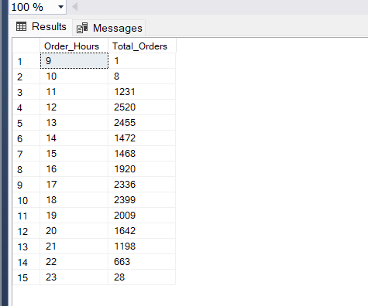

**6. PERCENTAGE OF SALES BY TOTAL CATEGORY**

SELECT pizza_category, CAST(SUM(total_price) AS DECIMAL(10,2)) as total_revenue,

CAST(SUM(total_price) * 100 / (SELECT SUM(total_price) from pizza_sales) AS DECIMAL(10,2)) AS PCT

FROM pizza_sales

GROUP BY pizza_category;

**7. PERCENTAGE OF SALES BY PIZZA SIZE**

SELECT pizza_size, CAST(SUM(total_price) AS DECIMAL(10,2)) as total_revenue,

CAST(SUM(total_price) * 100 / (SELECT SUM(total_price) from pizza_sales) AS DECIMAL(10,2)) AS PCT

FROM pizza_sales

GROUP BY pizza_size;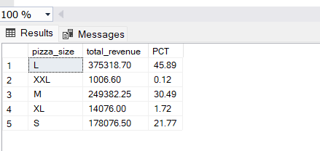

**8. TOTAL PIZZAS SOLD BY PIZZA CATEGORY**

SELECT pizza_category, SUM(quantity) as Total_Quantity_Sold

FROM pizza_sales

WHERE MONTH(order_date) = 2

GROUP BY pizza_category

ORDER BY Total_Quantity_Sold DESC;

**9. TOP 5 BEST SELLERS BY TOTAL PIZZAS SOLD**

SELECT Top 5 pizza_name, SUM(quantity) AS Total_Pizza_Sold

FROM pizza_sales

GROUP BY pizza_name

ORDER BY Total_Pizza_Sold DESC;

**10. BOTTOM 5 BEST SELLERS BY TOTAL PIZZAS SOLD**

SELECT Top 5 pizza_name, SUM(quantity) AS Total_Pizza_Sold

FROM pizza_sales

GROUP BY pizza_name

ORDER BY Total_Pizza_Sold ASC;

